**Introduction:**

In this analysis, we will be using the data of video game sales to analyze and organize the data to get meaningful results and useful insights so that we can come to a conclusion.

**Objective of the study:**

To find useful insights of the data using statistical approaches.

**Analysis:**

Our dataset has 16598 rows and 11 columns

The following table comprise of the frequency of variables present in the “Genre” column of our data set-

|  |  |
| --- | --- |
| GENRE | Frequency |
| Action | 3316 |
| Sports | 2346 |
| Misc | 1739 |
| Role-Playing | 1488 |
| Shooter | 1310 |
| Adventure | 1286 |
| Racing | 1249 |
| Platform | 886 |
| Simulation | 867 |
| Fighting | 848 |
| Strategy | 681 |
| Puzzle | 582 |

Pie Chart for “Genre:-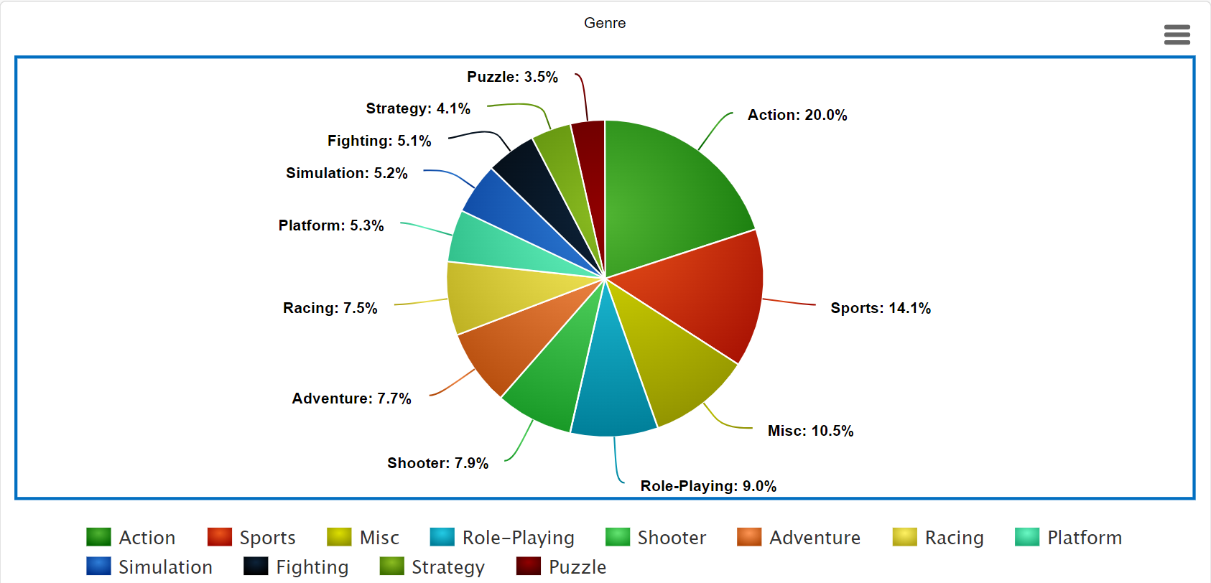

By the following Genre graph we can see that the most bought games were of type “Action” and the least bought were of type “Puzzle”

Now we will be calculating mean, mode and median for the same:

Total Sales(sum of frequencies):

16598

Mean= frequency/n=16598/13=

1276.76

Median=

1267.5

Mode=

3316, 2346, 1739, 1488, 1310, 1286, 1249, 886, 867, 848, 681, 582

Range=

2734

Minimum=

582

Maximum=

3316

Count *n*

13

Sum

16598

Quartiles

Quartiles:  
Q1 --> 857.5  
Q2 --> 1267.5  
Q3 --> 1613.5

Interquartile  
Range IQR

756

Outliers

3316

CONCLUSION:

We can conclude that north america is the top region has the highest average sales of $264,667.430